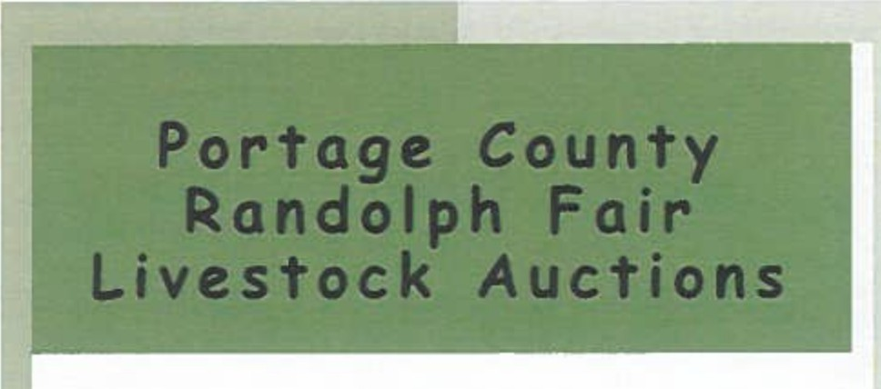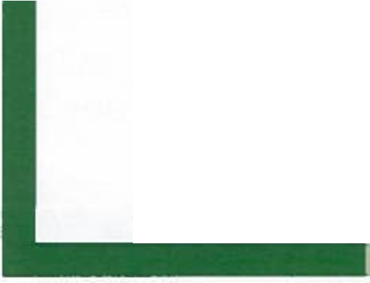

**New Sale Order/Days**

**2025**

***AUGUST 20TH WED.***

**Market Rabbits** & **Small Animals**

**@5:00pm**

**Sarchione Livestock Complex**

***AUGUST 23RD SAT.***

**Market Hogs @9:30am**

**Market Goats** & **Market Lambs**

**@3:00pm**

**Sarchione Livestock Complex**

**Market Steers**

**@7:00pm Hamilton Arena**

**THANK. YOU TO ALL SUPPORTERS**

**OF THE PORTAGE COUNTY RANDOLPH FAIR LIVESTOCK. SALES**

*THANK YOU to our*

*2024 DONORS/SPONSORS:*

***KIKO AUCTIONEERS***

*John Kiko* & *team* - *Canton, Ohio*

***DEERFIELD AG SERVICES***

*Deerfield, Kinsman, Louisville,*

*Massillon, Ohio*

***Horning, Sarchione, Innerst Wealth Management Group***

*Hartville, Ohio*

Portage County Randolph Fair Office

P.O. Box 213

(330)325-7476

Randolph, Ohio 44265 [www.randolphfair.com](http://www.randolphfair.com/) GPS: 4215 Fairground Rd.

Atwater, Ohio 44201

Fair Week: August 19-24, 2025

Portage Co. Livestock Sale Committee Contacts:

Tom Wise, President (330)428-2271 Debi Heppe, Treasurer (330)325-7128 or 330-592-6268

# Buyer Registration

**Updates have been made so please read carefully!**

**Market Livestock Buyers:** Previous year registered buyers will receive a mailing that explains buyer registration for this year's fair.

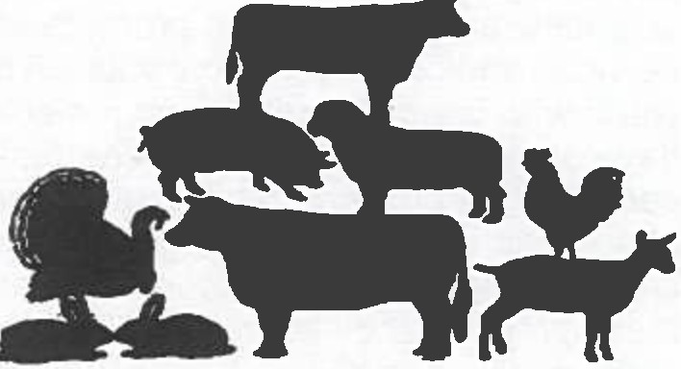For new buyers you will come to the buy­ er registration table on sale day and complete paperwork. You will need to provide general information, driver's li­ cense, and a working email address. At this time you will also select your proces­ sor (not needed for rabbit & poultry pur­ chases).

**ADD-ON Option:** A registered buyer can add an additional dollar amount to any exhibitor's market livestock sale .

**Add-Ons will now be done online at pcrandolphjrfair.fairentry.com.**

This can be completed starting August 17th through August 30th. **If you are cre­ ating a new buyer's account for only add-ons do not add an identifier (buyer number)**

**Donating back your livestock auction purchase:** If you wish to donate your purchased animal(s) for a **2nd sale** with those proceeds being donated to a Jr.

Fair Livestock fund then you **NO LONG­ ER** need two buyer numbers. Depending on the fund you choose to donate to you will have a letter representing that fund added to your buyer number and be giv­ en an additional bidder paddle for that option.

**General Information and Benefits**

**Options of What to Do with Animal After Purchase**

**How to Buy and**

**Terms of the Sale**

You are cordially invited to participate in this year's market livestock auctions during the Portage County Randolph Fair. The Jr. Fair auctions give you, as an individual or as a business, an opportunity to promote your services and/or support local youth. The youth who bring market animal proj�cts have dedicated their time and energies to care for their project(s) and to also learn about their animal(s). Raising an animal creates many valuable lessons and through these projects they learn about agribusi­ ness, quality assurance, livestock judging, marketing and working together. They also develop a strong work ethic and will use this knowledge in the future which will make our community better.

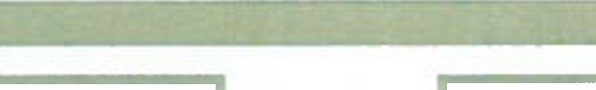

The youth, who participate in these projects, rely upon the funds received from the �uc­ tion to pay off investments and production costs and most will invest their profits in their future education. We are lucky to have many past participants return as adults to be advisors, volunteers, mentors, and support­ ers of the auctions.

Buyers will have their name listed in the barns with the animals they have purchased after the sale and will be included in future promotional releases. Previous_y�ar's buy­ ers will receive a sale day adm1ss1on pass for the fair in a special mailing prior to cur­ rent year's fair.

*Your support of the youth of the Randolph Fair is VERY IMPORTANT and VERY MUCH APPRECIATED!!*

1. Send your animal to be processed by one of the processors that part of our processor list. Purchas­ er pays for processing directly to processor, except rabbits & poultry.**

**All Poultry and Rabbits are processed at commit­ tee selected facilities. Buyers will have the pro­ cessing fee added to their invoice for the auction�. Poultry and Rabbits will be picked up after the fair on an assigned date at the fairgrounds.

1. **You can purchase an animal and donate it back to be sold a second time.** You will pay the total bid price for the first sale and the money from the second sale will be given to the Jr. Fair Live­ stock Fund you select. These funds include Po.

Co. Livestock Sale Scholarship, P.C. 4-H Scholar­ ship, P.C. 4-H Endowment Fun�. Dan Tr?nge Scholarship Fund or a 4-H club involved m market livestock projects.

1. ALL HOGS, POULTRY, RABBITS, BEEF STEERS & CHAMPIONS OF ALL SPECIES ARE

TERMINAL. Market ewe lambs, doe goats & beef heifers can be purchased & self hauled (Buyer is responsible to remove from fairgrounds). Wether goats & lambs can be self hauled, but must be har­ vested within 45 days of auction. A Sale Clerk **must** be notified by buyer on sale day so proper paperwork can be obtained for self haul. Complete this option as you check out.

1. You can donate the animal/meat to a local food shelf, the buyer is responsible for the processing costs & arrangements for delivery to selected.food shelf. You MUST make notation on buyer registra­ tion if you choose this option.

**ADD-ON OPTION: A** registered buyer can add an additional dollar amount to exhibitor(s) starting Au- gust 17th through August 30th at pcrandolphjrfair.fairentry. com

Please see other side ADD-ON section for more information.

1. All previous year buyers will receive a pre­ assigned bidder number. If you are a �ew b_uy­ er you will need to complete buyer regIstrat1on at the Buyer Registration table beginning ap­ proximately 1 hour prior to the auctions. Gen­ eral information needed: buyer's name, ad­ dress, phone, Driver's license and an active email address. If a business, we will need the name of business, contact person's name, business address, phone number, email ad­ dress and Driver's license for the authorized bidder.

Prospective buyers must also select a meat processor unless purchasing only small ani­ mals, or donating purchases back for a second sale. Animals may only be donated back one time. On the day of the auction you will pick up your bidder number at the appropriate table.

1. As each animal is sold, the auctioneer or ring men will take bids. Whethe� or not you �re successful in purchasing the animal, your bid will help the Jr. Fair youth & Market Livestock Auction.
2. When you have finished purchasing, you will need to proceed to the Sale Office and pay for your purchases. At this time, if planning to self-haul the, necessary paperwork must be obtained.
3. You MUST pay for the purchases the day of the sale. Payment can be made with Cash, "Good" check, Visa, Discover, or Master Card. There is a credit card processing fee that will be added to all credit card purchases.

2026 Fair Dates: August 25-30